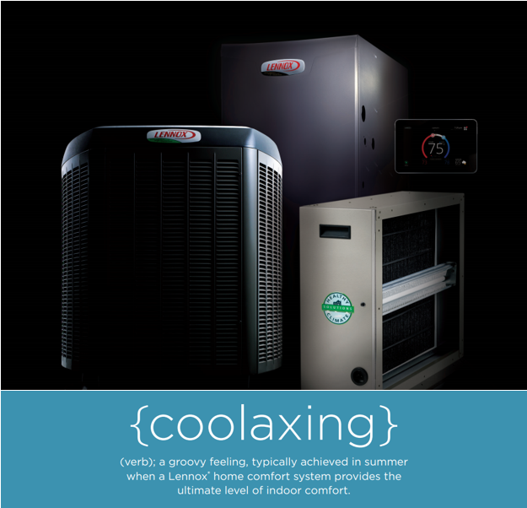

Take the heat out of summer with the precision comfort of our {coolaxing} deal. When the thermometer Is off the charts, you know that summer has truly arrived. Keeping your cool through months of constant heat can be a challenge. Luckily, our air conditioners from Lennox® are up to that challenge! The most precise and efficient air conditioner you can buy*†* can keep you cool, comfortable and energy efficient all summer long.

Call now and save with **REBATES UP TO $1,500* *OR* UP TO 60 MONTHS EQUAL PAYMENTS, NO INTEREST FINANCING** on qualifying equipment.**

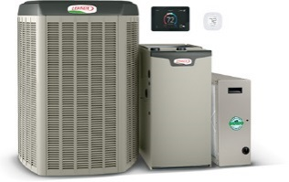**START WITH UP TO $1,200 IN REBATES.\***

Save on a complete qualifying Lennox® home comfort system that includes a gas furnace or blower coil, an air conditioner or heat pump and thermostat. Enjoy additional rebates when you purchase an iComfort® S30 Smart thermostat, iHarmony ® zoning and a PureAir™ system.

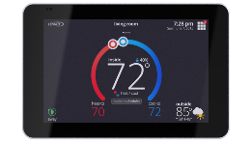**GET UP TO A $100 REBATE ON a WI-FI THERMOSTAT.\***

**OR,** TAKE ADVANTAGE OF OUR **FINANCING OFFER**

**Up to 60 MONTHS, EQUAL PAYMENTS, NO INTEREST FINANCING\*\***

Save now on the iComfort® S30 and save every month on utility bills. Anytime

your routine or weather changes, the iComfort S30 smartly adapts to reduce

your energy costs.

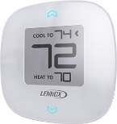

**GET UP TO A $100 REBATE ON ZONING.\***

Enhance your comfort and savings with iHarmony® zoning,

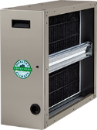a major advance in precision climate control.

**GET UP TO A $100 REBATE ON pUREAIR™.\***

Enjoy more savings and fewer pollutants with a PureAir™ system, which cleans

the air inside your home better than any other single system you can buy.

Top of Form

**Get comfortable now & CALL for details.**

*Some restrictions apply. System rebate offers range from $100-$1,200. Rebate offer is valid **June 25, 2018 through August 3, 2018** with the purchase of qualifying Lennox products. Cannot be combined with any other offer. Additional add-on rebates for iComfort® S30 Thermostat, iHarmony® Zoning System and Pure Air™ Air Purification System valid with a qualifying system purchase only. See your participating Lennox dealer for complete details. **Financing available to well qualified buyers on approved credit at a 0% APR for 60 months, with equal monthly payments. No down payment required. You may prepay your account at any time without penalty. Financing is subject to credit requirements and satisfactory completion of finance documents. Any finance terms advertised are estimates only. Normal late charges apply. See your Truth in Lending Disclosures for more information. © 2018 Lennox Industries Inc. Lennox Dealers are independently owned and operated businesses.Bottom of Form

*†*Efficiency claim based on comparison of air conditioning and heat pump products' SEER as published in AHRI (January 2015). Actual system combination efficiency may vary; consult AHRI for exact system efficiencies. Precision claim based on the cooling capacity range of the XC/XP25-036 units as compared to equivalent-sized competitive variable capacity compressor units.